Flow Chart

Main flow
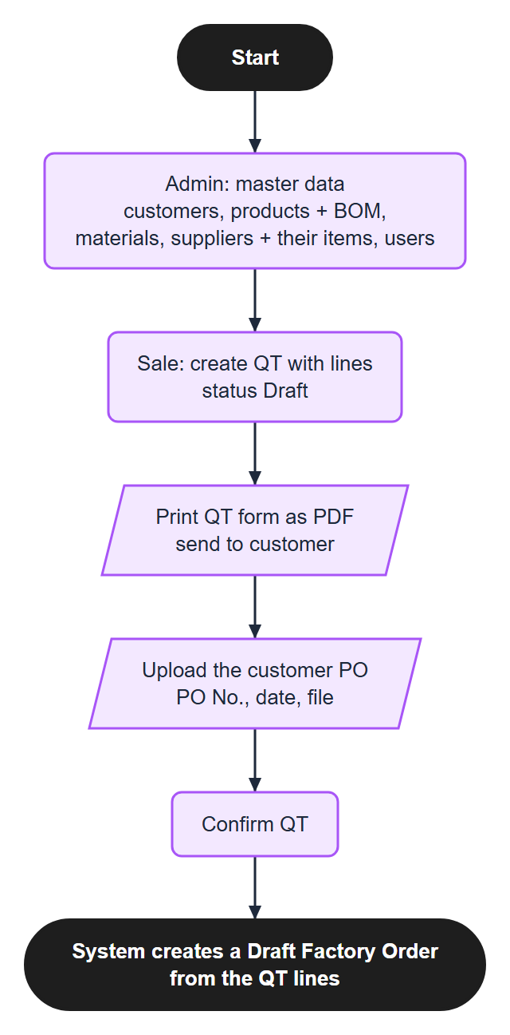
Figure 1. Main flow (1 of 3): from master data to the Draft order
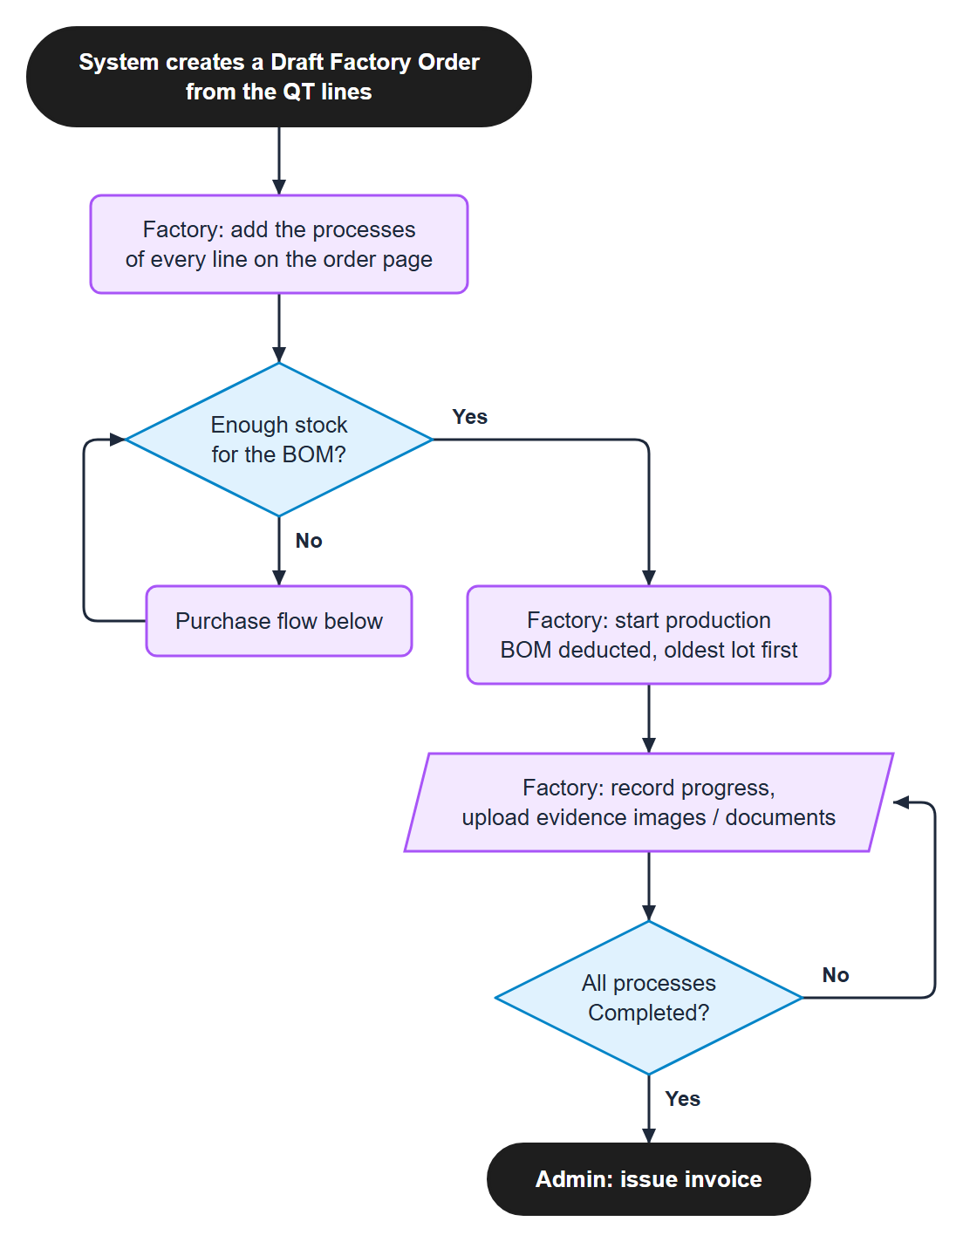
Figure 2. Main flow (2 of 3): production
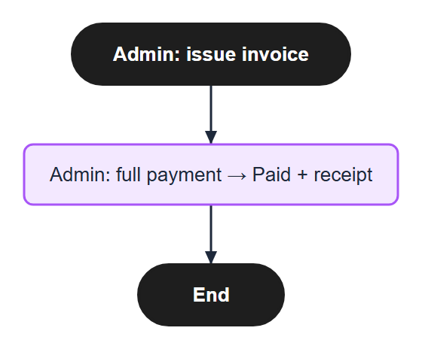
Figure 3. Main flow (3 of 3): invoice and payment

Purchase flow
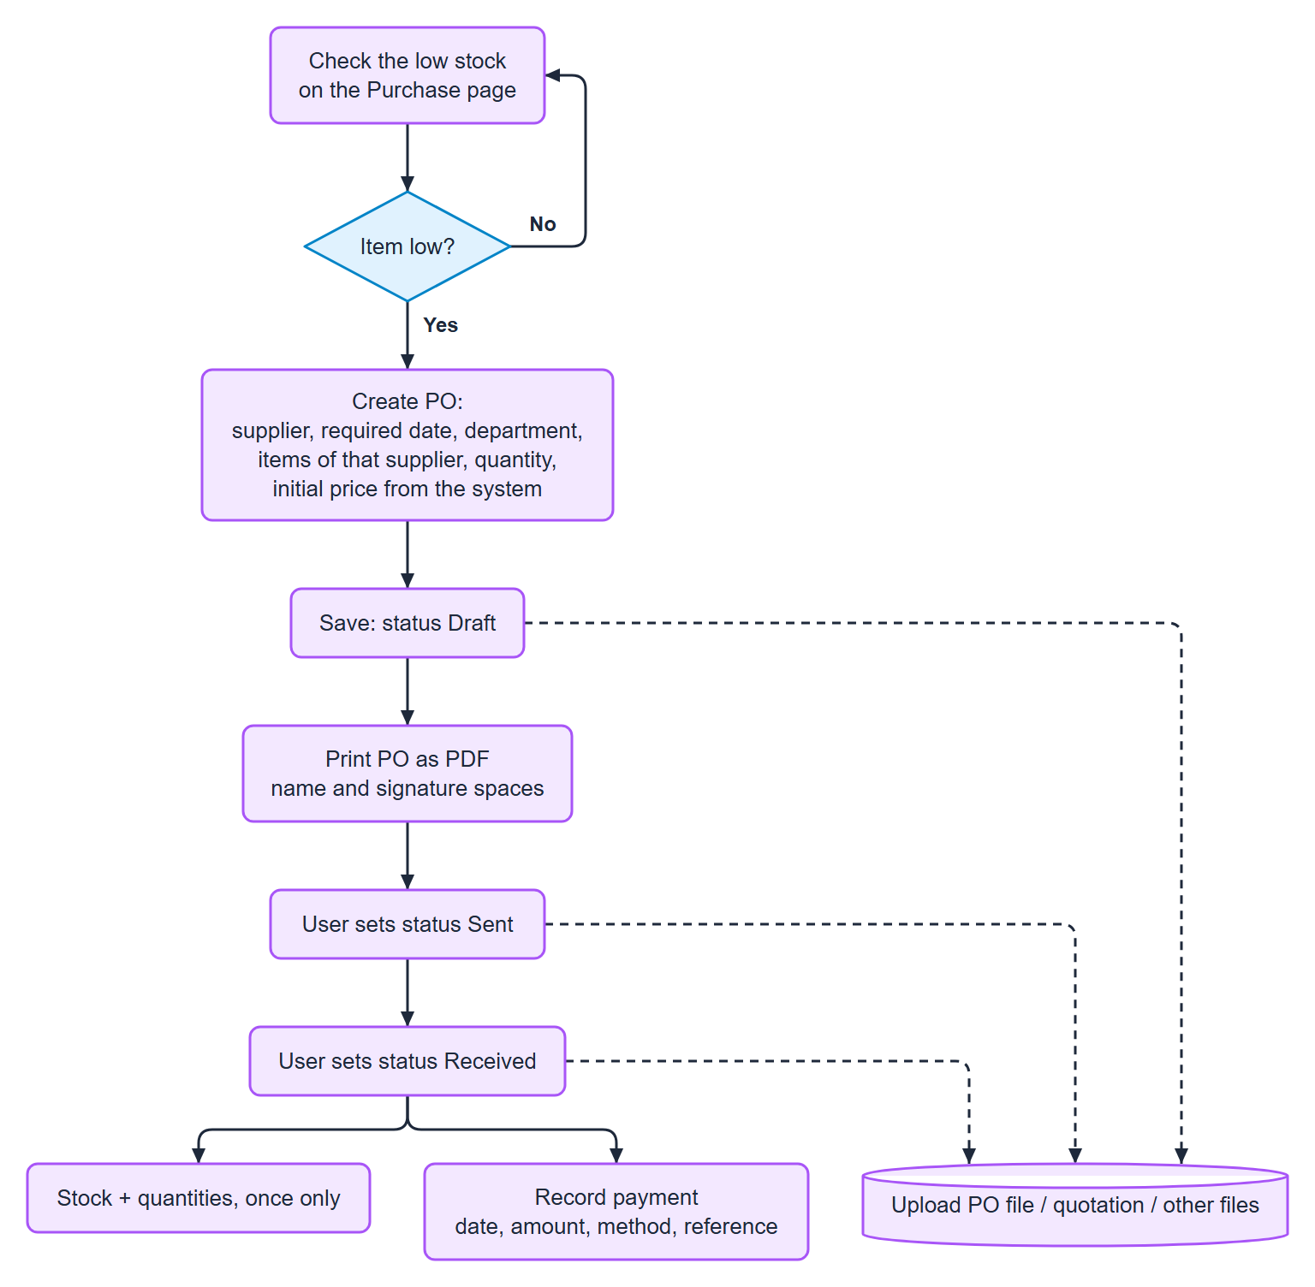
Figure 4. Purchase flow

PO status
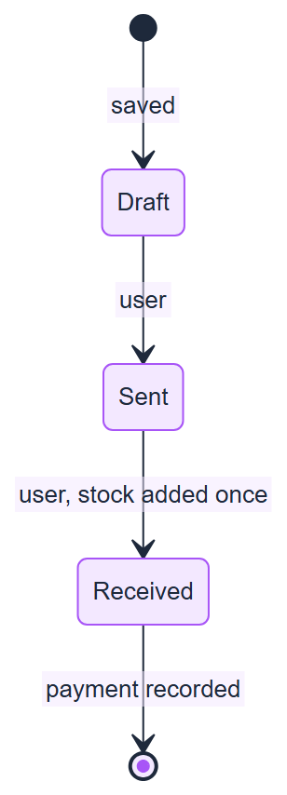
Figure 5. PO status
Lines can be edited only in Draft. A Draft PO can be deleted.

QT status
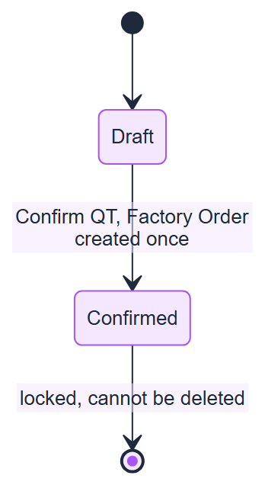
Figure 6. QT status

Order status
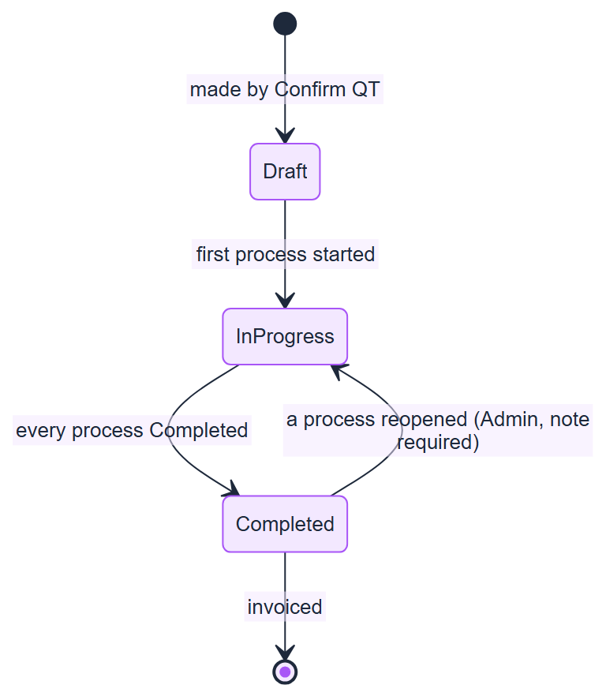
Figure 7. Order status
The status of an order is computed from its processes, not set by hand. Draft also covers an order that was started but has no progress yet (the page says "Production started").

Process status
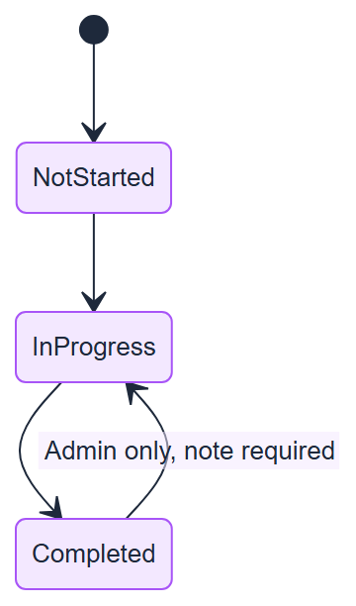
Figure 8. Process status

Invoice status
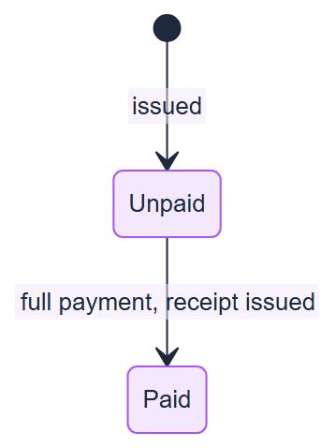
Figure 9. Invoice status

Stock changes
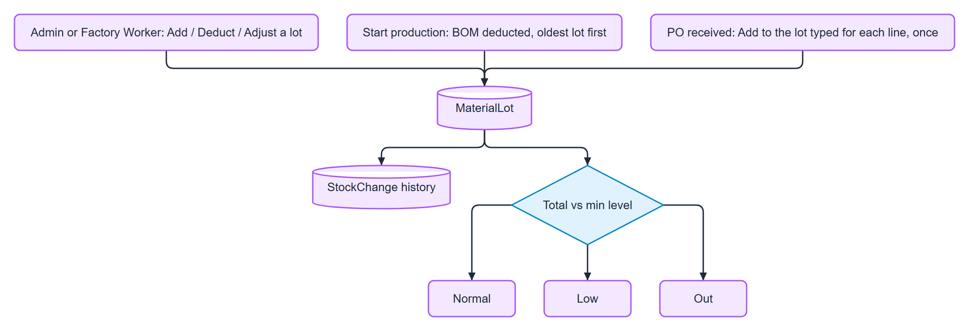
Figure 10. Stock changes

Confirm QT: checks
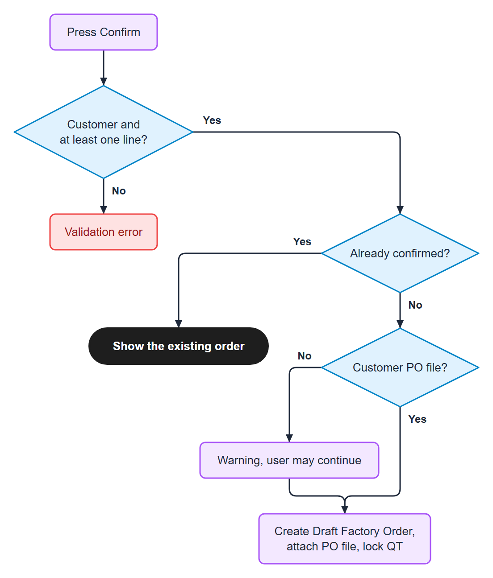
Figure 11. Confirm QT: checks

